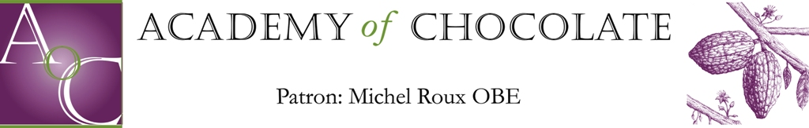

Terms and Conditions for Use of

The Academy of Chocolate Award Logo and Trademarks

All of The Academy of Chocolate's trademarks, logos, ratings, reviews, awards, editorial content, Web pages and other distinctive features (“The Academy’s Intellectual Property”) are protected by applicable trademark, copyright and other intellectual property laws.

Among The Academy’s Intellectual Property is The Academy of Chocolate’s Award logos and design (“Award Logo(s)”) as depicted herein:

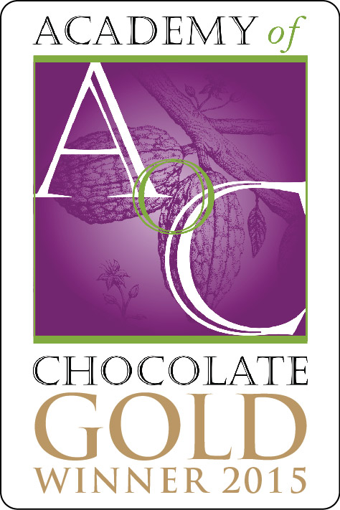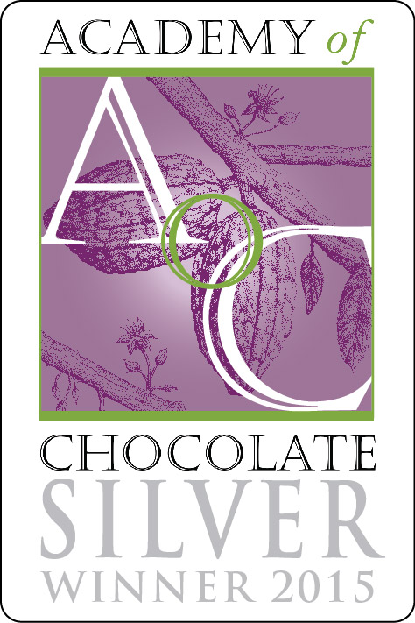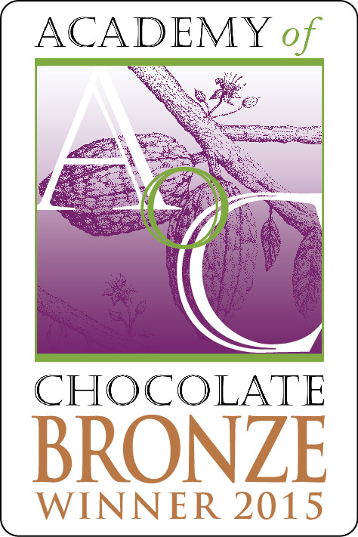

Use of the Award Logo may be made by Award recipients (“Users”) indefinitely or until notified by the Academy of Chocolate that the User no longer has a right to use the Award Logo and/or the Academy’s Intellectual Property (the “Term”). Users may only use the specific level of Award Logo they are awarded with (namely bronze, silver or gold).

When referring to the Academy of Chocolate Awards (the “Award”) in any medium (e.g., promotional, television, radio, print, etc.), Users agree to use the official Award title “Academy of Chocolate Awards” and will not refer to it in any other manner and/or name. A User must also reference the specific year, level of Award won by the User (namely bronze, silver or gold) and category for which the User won the Award.

This right to use the Award Logo is a non-exclusive, non-transferable, royalty-free worldwide license (which cannot be sublicensed) to use and display the Award Logo during the Term, for the purposes only and insofar as use is required to enable Users to publicize their status to the public, as noted below. Users may not create any derivative works and/or alternate versions of the Award Logo.

Users may use the Award Logo and/or reference the Award, level, category and year only in the following manner, unless with the specific written permission of The Academy of Chocolate:

- On a storefront sign;
- On packaging of product for which the award was granted (except for an Award granted in a category specifically for packaging, in which case the Award Logo may NOT be used on any packaging);
- In promotional materials;
- On the entity’s own web site;
- In the entity’s advertisements; and
- On a menu

Users acknowledge and agree that any and all use of the Award Logo pursuant to this license shall inure to the benefit of The Academy of Chocolate.

Users agrees that ownership of the Award Logo, and the goodwill relating thereto, shall remain vested in The Academy of Chocolate both during the Term of this Agreement and thereafter, and Users further agree never to challenge, contest or question the validity of The Academy of Chocolate’s ownership of the Award Logo covered by this Agreement.

Failure to abide by the terms of this Agreement may result in the revocation of an Award and/or bar from entry into the Awards for a period of two (2) years.

The Academy of Chocolate
April 2015

